**“The Bridge to Resiliency”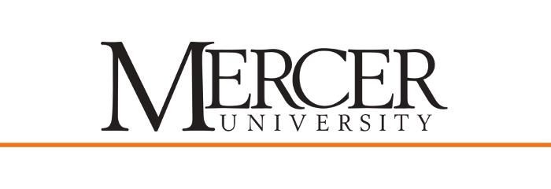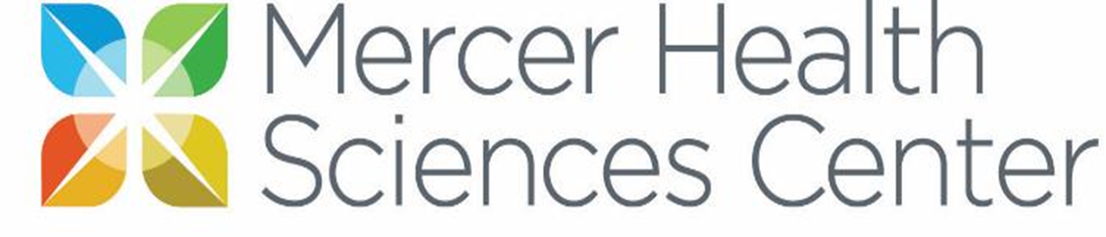**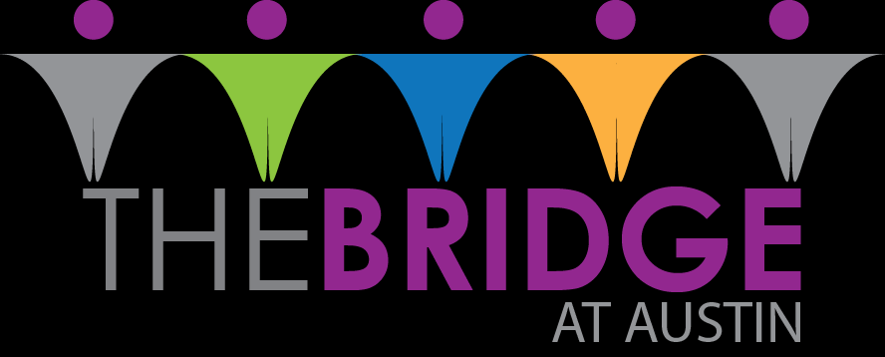

Researchers: Chelsea Gould, MPH-S, Rebecca Mortensen, PA-S, Dr. Thomas, DrPH, MSPH, Dr. May, PhD

**Public Health Issue:**

Around the world things have changed drastically in the past year. Most children have not been in school and getting the academic and social support they need. When schools in Dekalb county opened up classrooms in March, two-thirds of the students continued online learning (Dixon, 2021). For the kids going back to school in the fall many of them have not been in class, face-to-face with peers and teachers, in almost a year and a half. These children have missed out on certain skills because of this. Stress, anxiety, and anger may stem from the online relationships, lack of skills and home dependence that they have grown into. Resilience to these emotions and building coping skills will be crucial for the success of these children in terms of school, family and other relationships. Building on the abilities that are lacking can help these children adapt and grow during whatever comes next for our world.

**Intervention Program:**

This community-based project focuses on the mental health of children and the impact of COVID-19. We will be conducting key informant interviews to assess the needs of children ages 11 and 12 in terms of stress, anxiety, anger, relationship conflicts, life skills, independence, and resiliency. The information obtained from these interviews will help us guide the content for this program.

Kid friendly content will be created for four to five sessions. These will focus on building the coping skills and life skills that we see are of need in the population based on the key informant interviews. The content will then be taught in-person with a combination of inside and outside activities.

**Impact on the Community:**

This program will help children adapt to the state of the world as well as give them skills for their future. We hope to adapt this program to be able to use it in the future for classrooms/after school sessions, community centers and/or other camps.

**Partnerships:**

The saying goes, “two heads are better than one”. I can be extremely helpful to have advice and opinions of others, especially those in different areas of expertise. Public Health students will work together with Physician Assistant students, and community members, including past teachers and parents. These collaborations will serve the program well in creating something that is evidence-based and community driven.

**Get Involved:**

More professional and community based input will help us create this program in a well rounded way. A student group will be created to discuss articles, content creation and presentations. There will be opportunities to research certain topics/content, debrief others on articles and news that you have come across, share your ideas for content and other areas of the program process, and help present the content during the program. By joining the team you can add in one or more of these opportunities. Email [chelsea.linda.gould@live.mercer.edu](mailto:chelsea.linda.gould@live.mercer.edu) for more information.

**Reference**

Dixon, K. (2021). Thow-thirds of DeKalb Students Continue with Remote Learning Option. *The Atlanta Journal-Constitution*. Retrieved on April 14, 2021 from https://www.ajc.com/news/atlanta-news/two-thirds-of-dekalb-students-continue-with-remote-learning-option/FWR5ACROQBEYZIJRDHVF34YCJQ/